Online Store

Overview

Contents
Messaging 2
Quick Pitch 2
Top-line Benefits 2
Detailed Benefits 2
Features 4
Features Overview 4
Supported Gateways/Payment Processors 5
Customer Experience 7
Sales Support 13
Probing Questions 13
Selling Points 13
Objection Handlers 15
Frequently Asked Questions 17
General 17
Management & Installation 20
Plans & Pricing 21
Payment Integrations 21
Shipping 21
Full Feature List 24

Messaging

Quick Pitch
Sell online in no time with Online Store.
Build your business by selling products on your website with Online Store. Integrated directly within the Online Presence Builder, Online Store makes it simple to add products for sale and accept payments. It’s fast, safe and secure for you and your customers. It’s never been this easy to sell online.

Top-line Benefits
- Simple: Start selling products on your website in minutes with Online Store.
- Professional: Create a great looking online presence that uses modern themes, a free gallery of professional images, and simple, built-in ecommerce options.
- Accessible on any device: Online Store is optimized for mobile, so your storefront will look great across all devices.
- Ease of use: Online Store’s step-by-step set-up helps you automate currency, tax and easily set up shipping methods and rates.
- Safe and secure: Provide customers with secure payment processing using secure payment gateways, and industry leading verification technology to prevent fraud and guarantee safety of sensitive information.
- Cost savings: Online Store is an affordable and cost effective solution, with a low monthly subscription rate and no transaction fees.

Detailed Benefits

No Expertise Required | - Creating your store is easy; no technical knowledge necessary. Online Store will walk you through the steps of adding products and setting currency, shipping and any other required options.  - Online Store is directly integrated with Online Presence builder – no need to import in data or add HTML blocks, just select Online Store from your Add-Ons and an “Online Store” tab will be added to your existing website.
Responsive Design | - Your store will look great on any device as it automatically adapts to your customer’s screen size, from laptops, tablets to smartphones.
Social Integration | - Online Store seamlessly integrates your website with your Facebook page. You’ll be able to reach new customers by selling directly through Facebook!
Secure | - All data is safe and secure; all credit card and transaction data is transmitted via secure HTTPS protocols and follow gold standards for secure e-commerce.
No Transaction Fee | - We want to help your business succeed, which is why Online Store does not charge transaction fees. (Note: Payment processors may charge service transaction fees. Payment processors are third-parties that handle transactions such as credit card payments.)
Simple to Manage | - The easy-to-use Online Store dashboard will allow you to see a summary of store activity, sales and your catalog of products.  - Online Store allows tracking inventory on product level. You can define a quantity for each product separately.  - Product quantity is automatically reduced when an item has been bought.
Global Reach | - Sell globally with multi-currency support, over 40 international payment options, real-time shipping integration and support for 50 languages.

Features

Features Overview
One Seamless Experience | - Full-featured e-commerce platform is integrated within Online Presence Builder – simply click a button to add it to your website.  - Sell products directly on your website, blog and through Facebook.  - Customize how your store will look to customers; edit layout, colors, fonts and more.  - Mobile adaptive storefront (desktop, tablet, mobile).
Simple Onboarding | - Upload product images and tag their price to build your store.  - Follow these easy steps, to get you started selling online:  - Add Products – All we need is a product image, product name and the price of the product  - Verify Your Location – Country and Currency  - Set up how your products are delivered – Physical or Digital goods  - Set up your payment options  - Click Publish!
Adding Products | - Shopping cart supports gift cards, discounts codes, recommend products and more.
Accepting Payments | - Select the most suitable way to collect payments from your customers, including check, cash and credit card payments.  - Integrates with top payment providers like PayPal, Authorize.net or First Data to make online purchases with your store fast and easy.  - Safe and secure payment processing.  - Quickbook compatible.  - Customer can create profile or checkout without creating profile (configurable).
Social | - Free Facebook integration app; add your Online Store right to your Facebook page to sell your products through Facebook.
Customized Options | - Geographic and local customization automatically sets currency, tax and calculates shipping rates.  - Sync your company information across customer invoices and email notifications.  - Set-up shipping methods and rates. Real-time shipping quotes for UPS, USPS, FedEx, Canada Post, EMS Russian Post, Correios and Australia Post.
Tracking | - Customizable order email notifications to multiple recipients.  - Mange product inventory - product quantity is automatically reduced when an item has been bought. You will receive email notices when your stock is low.  - Order history for customers and administrator.  - Track payment and shipping status.  - CSV export for order, product and customer data.
Management | The main sections of the Online Store panel include:  - Dashboard: this page is occupied by an installation wizard that will guide you through all necessary setup steps to open an Online Store within Online Presence Builder, and display a sample summary of store activity (latest orders, store ID, total of sales, etc.).  - Sales: this page will display all orders made by your customers in your Online Store.  - Catalog: here you will load and manage your products and categories.  - Customers: this section will have a list of customers who have created profiles in your store.  - Promotion: several extra features to extend your selling experience, Coupons, Volume Discounts and third-party Marketplaces.  - System Settings: follow here to configure your payment methods, shipping, taxes, store languages, currency, etc.

Supported Gateways/Payment Processors
 | Sell 12 | Sell 100 | Sell 1000 | Sell Unlimited
PayPal Standard, PayPal Express Checkout, PayPal Advanced and PayPal Payflow Link, PayPal Payments Pro Hosted, PayPal Bill Me Later | Yes* | Yes | Yes | Yes
Stripe |  | Yes | Yes | Yes
2Checkout |  | Yes | Yes | Yes
American Express Payment Gateway |  | Yes | Yes | Yes
Authorize.Net SIM |  | Yes | Yes | Yes
Bancomer |  | Yes | Yes | Yes
Beanstream (Hosted Payment Form) |  | Yes | Yes | Yes
ClickAndBuy |  | Yes | Yes | Yes
e-Path |  | Yes | Yes | Yes
eWAY (Hosted Payment Page) |  | Yes | Yes | Yes
First Data Global Gateway e4 |  | Yes | Yes | Yes
iDEAL (via Mollie) |  | Yes | Yes | Yes
iPay88 |  | Yes | Yes | Yes
iPayment |  | Yes | Yes | Yes
Moneris SELECTplus (Hosted Paypage) |  | Yes | Yes | Yes
MultiSafepay ( iDEAL, credit cards, Giropay, DIRECTebanking, etc) |  | Yes | Yes | Yes
Network Merchants |  | Yes | Yes | Yes
Pag Seguro |  | Yes | Yes | Yes
Payeezy |  | Yes | Yes | Yes
PayFast |  | Yes | Yes | Yes
PayJunction |  | Yes | Yes | Yes
PayLeap |  | Yes | Yes | Yes
PayOnline System |  | Yes | Yes | Yes
Paytrail (former Suomen Verkkomaksut Oy) |  | Yes | Yes | Yes
PayU: India |  | Yes | Yes | Yes
QIWI |  | Yes | Yes | Yes
Realex Payments / Global Iris |  | Yes | Yes | Yes
Robokassa (Webmoney, Yandex.Money, etc) |  | Yes | Yes | Yes
Sage Exchange US |  | Yes | Yes | Yes
Sage Pay UK |  | Yes | Yes | Yes
TransFirst Transaction Express |  | Yes | Yes | Yes
Virtual Cart Services |  | Yes | Yes | Yes

Customer Experience
After you’ve activated Online Store, the onboarder will launch. You can also access the onboarder or management panel anytime by clicking on your Online Store in Online Presence Builder.
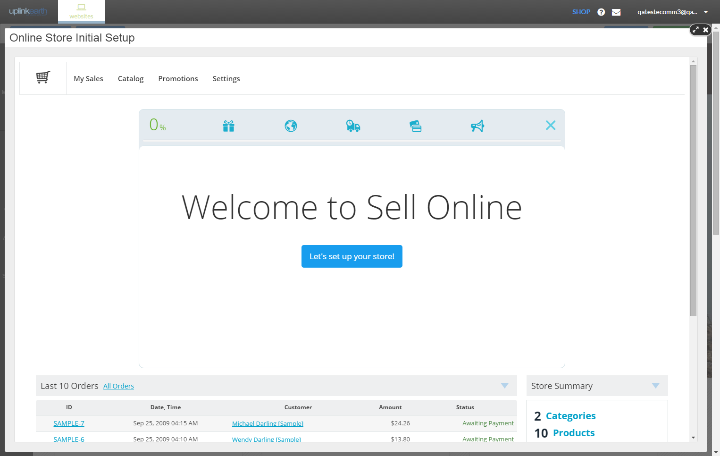

The onboarder will take customers through the necessary steps to get set up.
The first step is to add Products that you wish to sell online.
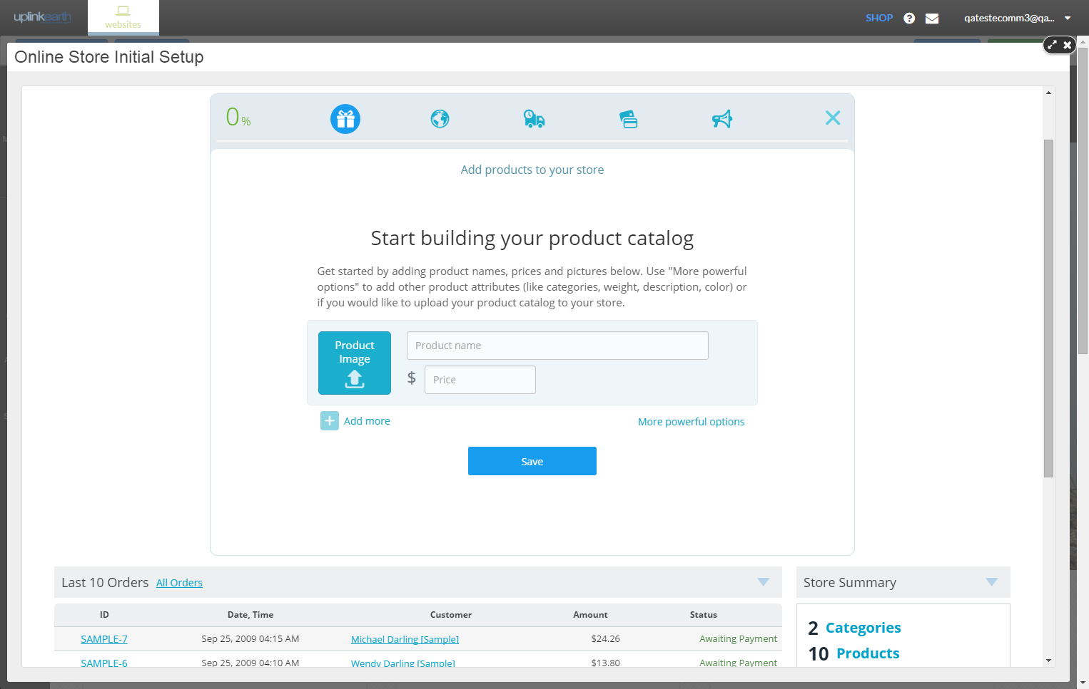
There are basic and advanced options for adding and managing products.
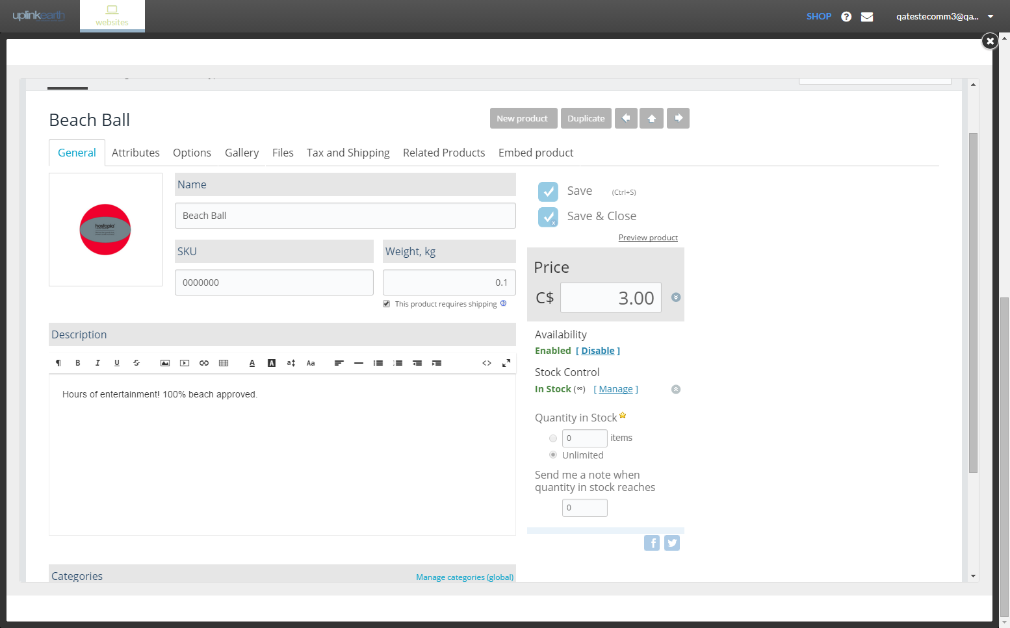
The next step is customizing your Online Store for your location.
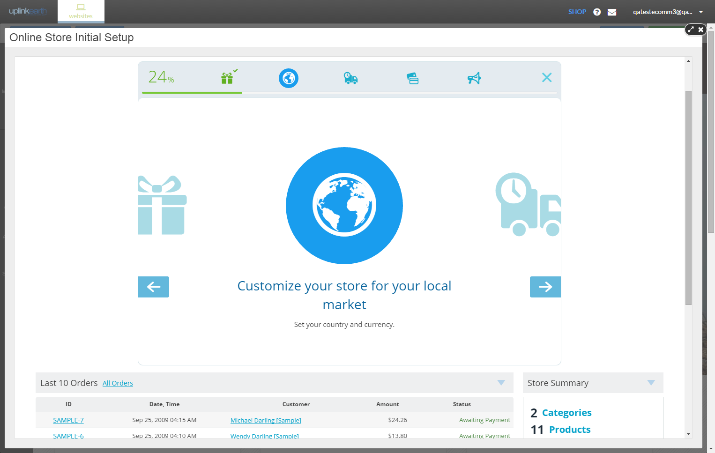
Here is where you set currency and metrics to display on your store.
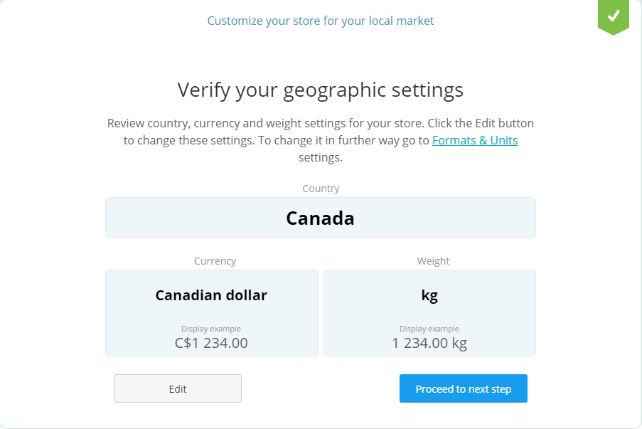
Next, set up shipping options. Define how items are shipped by setting up your carrier, rates and other shipping options.
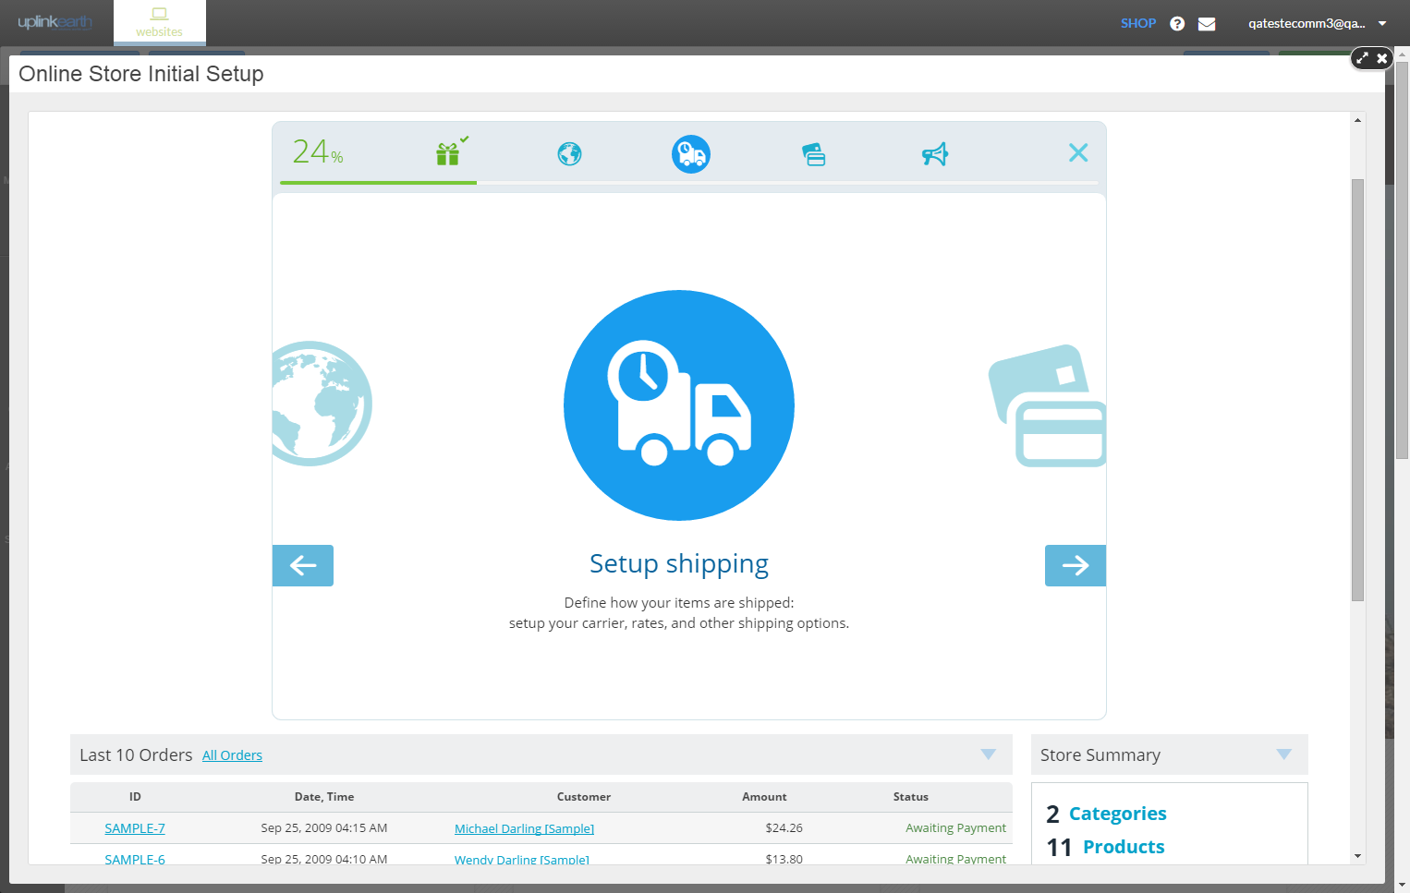
For example, choose a local carrier or set flat shipping rates by region.
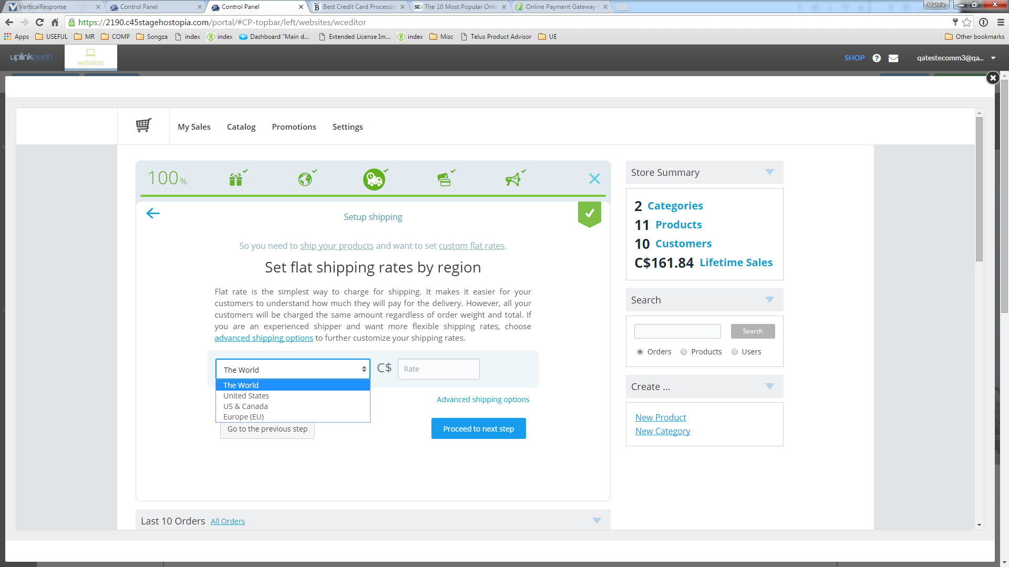
Finally, you need a way to receive payments! Set up your preferred payment option.
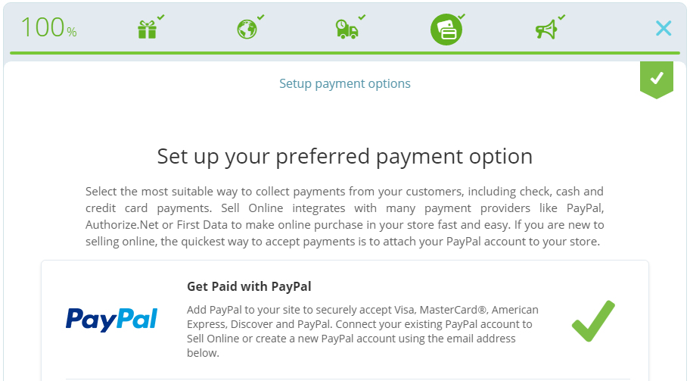
With Sell 100 or higher, you can unlock more payment options.
And that’s the simple set-up!
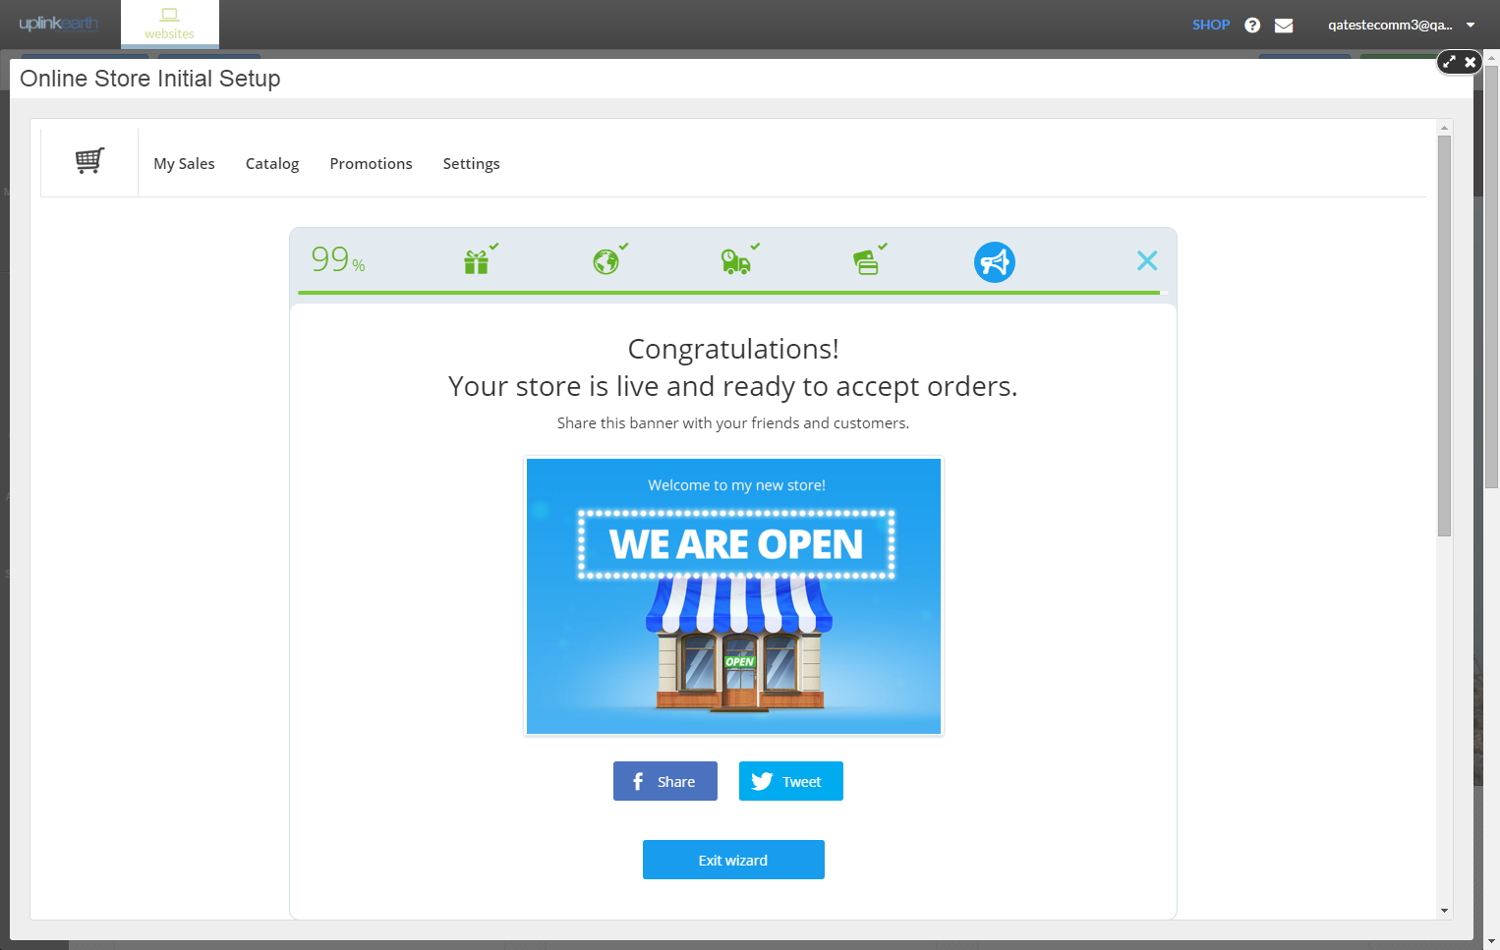
Access your sales, catalog and settings in the Online Store panel. Customize your settings, including shipping carriers, design of your store, customer and automated notifications, invoicing and more.
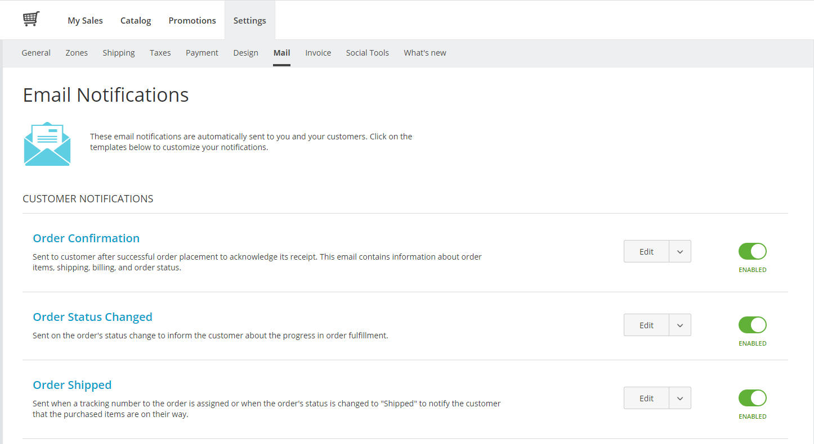
It’s never been easier to set up an online store. Be proud of your finished product:
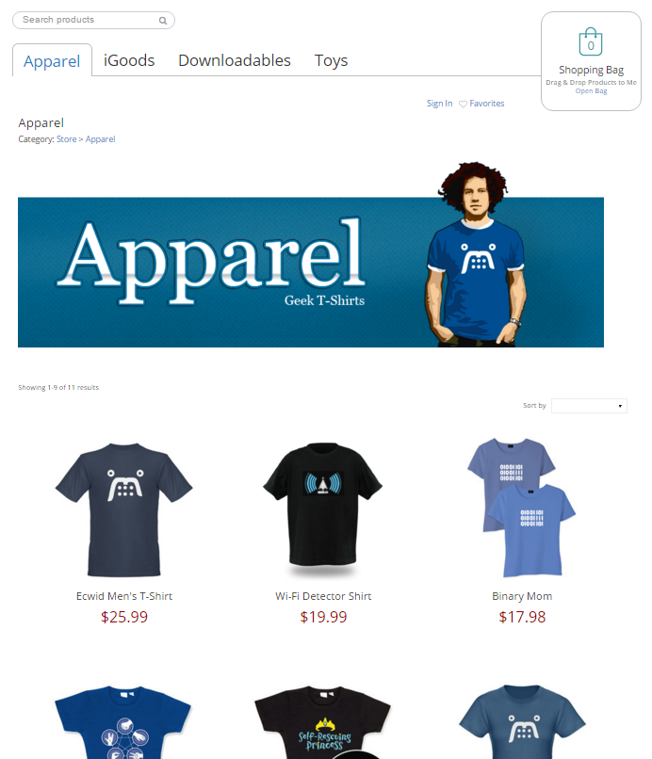

Sales Support

Probing Questions
Are you currently selling products on your website with an Online Store?

- No.
  - With more people going online first to search for products and services, you want to be in a position to convert these shoppers into buyers by offering them the ability to purchase online.
  - Getting started to sell online is simple. Setup your store in minutes. An easy to use onboarder walks you through adding the product and details and setting basic tax and shipping rates.
- Yes. That’s great.
  - Is it easy to manage?
  - Do you have to use a different tool to manage your storefront versus your website?
  - Do you have proper reporting to manage your product inventory, order history and track payment and shipping status?
  - Are you paying transaction fees with your current solution?

Do you have a Facebook page?

- Yes? Great, Online Store can actually be integrated right into your Facebook page, as a new tab. It’s quick and easy and you can be selling through your Facebook page today.

- No? Facebook business pages are free, and in just a few minutes you can be selling your products through the most popular social network with Online Presence Builder.

For business that provide services to customers:
Have you thought about selling gift certificates?

You don’t have to sell products to sell online. As a business that sell services, you can offer your customers the ability to purchase gift certificates that you can use towards the future purchase of services that you may offer. Consider using gift certificates to sell products during high-opportunity occasions, such as Valentine’s Day, birthdays, Halloween or the holidays.

Selling Points
Establish an online presence. Customers are more apt to trust businesses with a professional, up-to-date website. Consumers often use websites to “window shop” and compare products and pricing. Having a professional online store will not only drive online sales for your business with new customers and new markets, but help drive traffic into your business.

Sell anytime, anywhere, on any device. Online Store adapts to any device so it looks great across smartphones, tablets and laptops. Today, more customers are using their smartphones than desktops to browse for products and services online, and it’s important your business shows up.

Increase sales. For a few extra dollars a month, you can be taking orders from your website 24/7. It’s one of the most cost-effective ways to increase your sales and attract new customers.

Build your customer database. Online Store lets customers create profiles for simple purchasing, which can help you build a strong base of repeat customers.

Why should I choose Online Store?
- Online Store is managed directly within Online Presence Builder, so you can add an Online Store to your existing or new website that is fully branded and responsive, with the same look-and-feel as your website.
- Online Store is optimized for mobile, so your storefront will look great across all devices.
- Online Store’s step-by-step set-up helps you automate currency, tax and easily setup shipping methods and rates.
- Unlike other e-commerce solutions, Online Store is managed with the same tool as your website, doesn’t charge any extra transaction fees, and has incredibly low-cost, high-value return.
- Some other e-commerce solutions require extra steps to making sure your storefront is secure; Online Store is PCI-DSS Level 1 Service Provider Certified, which just means it’s a certified secure solution for you and your customers.

Competitive Information
How does Online Store compare to other e-commerce options in the market?
Features | ONLINE STORE | BIGCOMMERCE | SHOPIFY | WOOCOMMERCE | PRESTASHOP
What is it? | Shopping cart within Online Presence Builder. | Template-based e-Commerce store builder. | Template-based e-Commerce store builder. | e-Commerce toolkit/plug-in for WordPress. | Open source e-Commerce solution.
Set-up | Simple 5-step wizard (add a product, set currency, pick shipping option, select payment method and you’re done) and intuitive management. | Length set-up process without step-by-step wizard. No “basic” versus “advanced” options. | Lengthy set-up process; without “basic” versus “advanced” options. | Fairly simple onboarding process. | Users need a separate hosting provider. Requires software download and installation. Customization requires coding knowledge.
Site Integration | Online Store instantly creates a store tab on your existing website. Manage your store set-up and products and inventory right through Online Presence Builder. | Additional templates with separate setups and updates. No simple way to integrate with your existing website. | Multi-step, multi-platform process: add the product in Shopify, and then generate a buy button. Copy and paste the embed code provided into your existing website. | Integration with WordPress sites; still requires technical steps to install plug-in. Additional templates with separate updates. | Technical set-up: adding to your hosting account requires file management via File Manager or FTP and database set-up. Separate store will be added to a subdirectory of your website.
Security | PCI-DSS* Level 1 Service Provider Certified; store pages HTTPS secure. | PCI-DSS; store pages HTTPS secure. | PCI-DSS; store pages HTTPS secure. | Requires merchants to attain certification from their hosting provider. | PHP open source software is reputed as bug ridden and has been breached in the past.
Transaction Fees | No transaction fees. | $0.30 per transaction. | 0.5-2.0% for external payment gateways. | No transaction fees. | No transaction fees.
Pricing | Online Store has four affordable options for small business, starting at a few extra dollars a month. There are no hidden costs, everything you need is included in your Online Store add-on option. | Monthly fees range from $29.95 per month (Standard Plan) to $79.95 per month (Plus Plan) to $199.95 per month, with maximums on sales generated from your Bigcommerce storefront. | Plans start at a monthly price of $9 (no store support, only shopping cart) for a Lite plan, and moves up to $29 for Basic, $79 for Pro, and $179 for Unlimited. | “Free” for very basic features. One time fees (currently $79) for connecting payment gateways and other customizations (shipping options, extended product details, importing data and more). | “Freemium” model, where very basic features are free and customizations cost extra, plus you need to pay for your hosting, domain, security and support.
* Payment Card Industry Data Security Standard (PCI DSS) is a worldwide information security standard defined by the Payment Card Industry Security Standards Council. The standard was created to help payment card industry organizations that process card payments prevent credit card fraud through increased controls around data and its exposure to compromise. The standard applies to all organizations that hold, process, or exchange cardholder information from any card branded with the logo of one of the card brands.

Objection Handlers
Selling online is difficult, and I don’t have time to manage it.
The good news is that it has never been easier to start selling online. Anyone can do it and it only takes a few minutes of time to get started.
There’s a quick step-by-step onboarder that walks you through how to start adding products, how to setup your currency settings and shipping options. Lastly the onboarder will help you setup your payment options and Payment Processor.
The store will automatically send you an email when an order is placed, and keep you notified when your stock is running low. Online Store does all of the heavy lifting so you don’t have to.
I already have a website and I don’t want to rebuild it on your system.
Online Presence Builder makes it easy to manage your website and store in one place; and if you have an existing website then you can easily add Online Store in a few clicks.
Unlike other ecommerce companies our Online Store offers a great deal of flexibility allowing you to completely integrate with your current Online Presence Builder website.
That means you will not have to rebuild anything!
People would rather shop in store instead of online.
Actually, that’s becoming less and less true. Shoppers are looking for more convenience when purchasing. Attitudes towards purchasing online have changed as more and more shoppers confidently will purchase all kinds of product and services (big or small) online.
Two thirds (69 percent) of US online adults shop online at least monthly*.
In today’s busy world customers appreciate being able to buy products and services with a few clicks! Your goal should be to making buying your products as easy as possible.
In fact, having an online store will help drive customers through your doors. Consumers are using online stores to “window shop”, to check what you have available and compare features and pricing. 81% of people look at products online before making a purchase in store.**
*Mintel’s Online Shopping US 2015 report
**GE Capital Retail Major Purchase Shopper Study
I’d rather invest in social.
With Online Store you can sell your products directly on your Facebook page! This gives your customers a convenient way to buy your products while syncing directly to your central inventory. You can add Online Store to multiple websites, blogs or social media pages, all while managing it in one spot. This makes managing your online presence incredibly simple, and strengthens your brand across sites.
I don’t have 100 products to sell, so I only need Sell 12.
The higher level Online Store options have lots of other great features to help you customize your online store.
Sell 12 only supports PayPal, which is a really great way to get started selling online. But you may want to look at using other Payment Gateway providers that offer more customizations and flexibility, such as Stripe.
Upgrading to Sell 100 allows you to customize your email notifications to customers, which is really important for branding and your customers remembering you.
Sell 100 also lets you enable social sharing from your products pages, so visitors can share and help promote your business. Plus other features like discount coupons, Favorites/Wish list, inventory tracking, real-time shipment tracking, and a bit more advanced tracking and reporting.
Sell 1000 and Unlimited lets you add in volume discounts, and has a ton more third-party integration options.

Frequently Asked Questions

General
What is Online Store?
Online Store is a powerful shopping cart/storefront that seamlessly integrates with your existing website. It’s an add-on feature within the easy-to-use cloud-based Online Presence Builder, which allows anyone to build impressive websites that perform on every screen, and helps you get found online.
With Online Store, anyone can add products for sale, set tax and shipping rates, and receive automatic notices when you receive orders online.

How can I accept payments; how does selling online work?
Online Store provides various different payment methods, starting from accepting credit cards via PayPal to manual order processing. With Sell 100 or above, you will be able to connect your store to major payment processor such as PayPal, Authorize.Net, Stripe, 2checkout and many more.
Online Store doesn't store or transfer the money to you; rather it serves as a go-between in processing payments. Online Store keeps your customers' and orders data and provides you with tools to arrange payments and manage the orders.
‘Payment Methods’ in Online Store is where you set a way to receive payments. Generally every online store can support two types of payment methods: online and offline.
Online payment means that the funds are transferred to you (to your payment account) virtually immediately the customer confirms the payment. Online payments are typically handled via a Payment gateway, an e-commerce application service provider service that authorizes credit card payments. If the credit card information submitted to the payment gateway matches the information on file with the credit card company and the charge is approved the payment gateway will then transfer the money from your customer’s credit card into your merchant account. The merchant account is basically an online bank account that will temporarily hold your money (you are the merchant) until it is moved into your actual bank account. After a successful sale, money will be transferred into your merchant account and it will sit there for a few days, usually between 2 and 7 days, then, in most cases, it will automatically be transferred into your bank account.

How do I ship my items?
Online Store offers you a flexible mechanism to calculate and charge delivery rates. Choose a local carrier or set flat local, national and worldwide shipping rates.

Can I charge sales taxes?
Yes, you can setup different tax rates for many regions worldwide as well as within your country.

Is my store secure?
Yes, absolutely. Online Store is PCI-DSS* Level 1 Service Provider Certified. We use highly secured and trusted platforms to store your Online Stores information.
Payment Card Industry Data Security Standard (PCI DSS) is a worldwide information security standard defined by the Payment Card Industry Security Standards Council. The standard was created to help payment card industry organizations that process card payments prevent credit card fraud through increased controls around data and its exposure to compromise. The standard applies to all organizations that hold, process, or exchange cardholder information from any card branded with the logo of one of the card brands.

How can I upgrade my account?
You can upgrade your account at any time right from the Online Presence Builder ‘Add-ons’ left hand interactions panel. Just follow these easy steps:
- Open Online Presence Builder from your Portal. Please make sure that you're logged in to the account you want to upgrade.
- Go to ‘Add-ons’ within the left hand interactions panel of Online Presence Builder.
- Select the ‘Online Store’ button and click ‘Learn More’.
- Select the Sell Online plan that you would like to upgrade to. If you do not have the amount of Web Points required you can purchase more by following the system prompts.
- Once activated, you will be able to access additional features by selecting the Online Store element from ‘Add-ons’ or clicking on your Online Store tab in Online Presence Builder.

What happens if I downgrade Online Store plans?
If you downgrade your account the functionality included within the higher of the two plans will be gone from your Online Store settings. In case you have more products in your store than are included in the plan you are downgrading to, you will be prompted to delete the products exceeding the limit of the plan. Your store will still be available to your customers so you can continue selling.
How can I downgrade my account?
You can downgrade your account at any time right from the Online Presence Builder ‘Add-ons’ left hand interactions panel. Just follow these easy steps:
- Open Online Presence Builder from your Portal. Please make sure that you're logged in to the account you want to downgrade.
- Go to ‘Add-ons’ within the left hand interactions panel of Online Presence Builder.
- Select the ‘Online Store’ button and click ‘Learn More’.
- Select the Sell Online Plan that you would like to downgrade to, upon selecting this plan the difference in your Web Points will be automatically adjusted and made accessible to you to purchase additional products.
- From successful downgrade your store plan will automatically change and provide you with the features that are included with your new plan.

Can I cancel my subscription?
You can cancel your subscription by calling into customer service.

Do you charge transaction fees from the sales on my store?
No, we do not charge the transaction fee from your sale.
However, the payment gateway you choose to process orders online may charge transaction fees and other service fees. A payment gateway is an e-commerce application service provider service that authorizes credit card payments. There are free and affortable options; be sure to be familiar with all important details and potential fees associated with your chosen payment gateway.

Does Online Store comply with PCI/PA DSS standards?
Online Store is a PCI-DSS validated Level 1 Service Provider.
Payment Card Industry Data Security Standard (PCI DSS) is a worldwide information security standard defined by the Payment Card Industry Security Standards Council. The standard was created to help payment card industry organizations that process card payments prevent credit card fraud through increased controls around data and its exposure to compromise. The standard applies to all organizations that hold, process, or exchange cardholder information from any card branded with the logo of one of the card brands.

Where can I access help information?
You can access help information at any time right from the Online Presence Builder ‘Help Icon’ left hand interactions panel. Just follow these easy steps:
- Open Online Presence Builder from your Portal.
- Go to ‘Help’ within the left hand interactions panel of Online Presence Builder.
- You now have access to a variety of helpful information on how to manage your Online Store and Online Presence.

How do customers buy my products?
Here are the basic steps associated to making online purchases:
- Customer browses your Online Store catalog, adds an item(s) to the bag, and goes to checkout (opens their bag and clicks 'Checkout' button).
- Customer then inputs a shipping address (if the items are shipped) and picks up a shipping method.
- Customer chooses a preferred payment method, and inputs their billing address.
- Completes the order.

Step #4 can be divided into more steps, and differs depending on what payment method is chosen.
Online Store doesn't store or transfer the money to you; rather it serves as a go-between in processing payments. Online Store keeps your customers' and orders data and provides you with tools to arrange payments and manage the orders.
‘Payment Methods’ in Online Store is where you set a way to receive payments. Generally every online store can support two types of payment methods: online and offline.
Online payment means that the funds are transferred to you (to your payment account) virtually immediately the customer confirms the payment. Online payments are typically handled via a Payment gateway, an e-commerce application service provider service that authorizes credit card payments. If the credit card information submitted to the payment gateway matches the information on file with the credit card company and the charge is approved the payment gateway will then transfer the money from your customer’s credit card into your merchant account. The merchant account is basically an online bank account that will temporarily hold your money (you are the merchant) until it is moved into your actual bank account. After a successful sale, money will be transferred into your merchant account and it will sit there for a few days, usually between 2 and 7 days, then, in most cases, it will automatically be transferred into your bank account.
Offline payment implies that the money is transferred later since the customer is supposed to arrange the transfer offsite: for ex., go to a nearby bank to transfer the money (that would be bank/wire transfer payment method), or you should give the customer a call to agree on the payment ("Phone order" payment method), or customer will give cash to the courier, etc.

I want to accept credit cards.
The process of receiving money for your sales via an online payment method involves three parties:
- Your Online Store within Online Presence Builder
- Payment gateway: special system, located outside your store but connected to it on programming level, that processes your customers' credit cards (or e.g. PayPal accounts) and does charging
- Your merchant account at the payment gateway connected to your bank account.
To put it simply, your store connects to the payment gateway, transmits the order details, the payment gateway processes customer's credit card and transfers the money to your merchant account. Then you can withdraw the funds to your bank account.

What do I need to start accepting credit cards?

- Open a bank account where you will transfer the money from your purchases.
- Find a payment company/processor from the list in Appendix #1 (PayPal is the simplest to start with).
- Sign up for an account with the chosen company.
- Configure the payment method in your Online Store according to instructions from our knowledge-base.
- Make sure it works properly. A recommended way would be to create a test product at, e.g., $0.01 and try to buy it as a usual customer. If the payment is setup correctly, your order will be recorded in Accepted status in your Online Store panel within Online Presence Builder.
Can Online Store Track Inventory?
Online Store allows tracking inventory on product level. You can define a quantity for each product separately. Product quantity is automatically reduced when an item has been bought. When the quantity reaches zero, the product gets “Out of stock” status and can’t be ordered anymore. The Online Store administrator gets notified about it.

Management & Installation
How do I manage my store?
All store setup and information on your customers and orders are done from the Online Store panel within Online Presence Builder located in the ‘My Add-ons’ left hand interactions panel. If you have not yet added the Online Store you must first do so by going to the ‘Add-Ons’ left hand interactions panel. Once you add Online Store, you will receive the access to this panel within My Add-ons, your Online Presence will also have an Online Store page automatically setup for you within your Online Presence site menu.

How do I setup my store?
We have made this as easy as possible for you, after selecting Online Store within My Add-ons upon the first instance we provide you with an easy to follow Online Store setup wizard. Just follow these easy steps, to get you started selling online:
- Add Products – get used to adding products for sale by adding a product image, product name and the price of the product.
- Verify Your Location – Country and Currency.
- Set up how your products are delivered – Physical or Digital goods.
- Set up your payment options.
- Click Publish!

The main sections of the Online Store panel include:
- Dashboard: This page is occupied by an installation wizard that will guide you through all necessary setup steps to open an Online Store within Online Presence Builder, and display a sample summary of store activity (latest orders, store ID, total of sales, etc.)
- Sales: This page will display all orders made by your customers in your Online Store.
- Catalog: Here you will load and manage your products and categories.
- Customers: This section will have a list of customers who have created profiles in your store.
- Promotion: Several extra features to extend your selling experience, Coupons, Volume Discounts and third-party Marketplaces.
- System Settings: Configure your payment methods, shipping, taxes, store languages, currency, etc.

Plans & Pricing
What Online Store Plans are available?
Online Store features four plans, each available through the Web Points system:
Sell Online 12 Products – 25 Web Points
Sell Online 100 Products – 100 Web Points
Sell Online 1,000 Products – 200 Web Points
Sell Online Unlimited Products – 400 Web Points
For a listing of production features, please see Appendix 1 of this document

I see the number of product limits that I can sell change by plan, why else should I upgrade other than product limits?
The higher level options have lots of other great features to help you customize your online store.
Sell 12 only supports PayPal, which is a really great way to get started selling online. But you may want to look at using other Payment Gateway providers that offer more customizations and flexibility, such as Stripe.
Upgrading to Sell 100 allows you to customize your email notifications to customers, which is really important for branding and your customers to remember you. Sell 100 also lets you enable social sharing from your products pages, so visitors can share and help promote your business. Plus other features like a discount coupons, Favorites/Wish list, inventory tracking, real-time shipment tracking, and a bit more advanced tracking and reporting.
Sell 1000 and Unlimited lets you add in volume discounts, and has a ton more third-party integration options.

Payment Integrations
Do you integrate with QuickBooks or other accounting software?
With our APIs, you can pass data from the sales records in your Online Store to your own accounting software.

What payment gateways are supported in my country?
View the available options in System Settings > Payment. There is also a comprehensive list of available payment gateways supported by Online Store by referring to Appendix #1 of this document.

Can I sell event tickets within my Online Store?
Absolutely! Online Store can be used to sell just about anything. To provide a digital ticket customized based on the customer, an event booking software combined with our Order API can do so. If it is a physical ticket, it can just be shipped to the customer.

Shipping
Can drop-shippers use Online Store?
Yes! We have many customers who use drop shipping services. In fact, Doba, one of the largest US based drop-shipping fulfillment companies recommends their customers to Online Store. Also, merchants can enter their fulfillment service’s email address in System Settings > Mail to receive order notifications automatically. Bonus!

Full Feature List
Plan | Sell 12 | Sell 100 | Sell 1,000 | Sell Unlimited
Web Points Required to Activate | 25 | 100 | 200 | 400
Transaction Fees | None | None | None | None
Product limit | 12 | 100 | 1000 | Unlimited
Categories | Unlimited | Unlimited | Unlimited | Unlimited
Storage | Unlimited | Unlimited | Unlimited | Unlimited
Bandwidth | Unlimited | Unlimited | Unlimited | Unlimited
Shopping Experience
Mobile Adaptive Storefront Widget (desktop, tablet, mobile) | Yes | Yes | Yes | Yes
Favorites/Wish list |  | Yes | Yes | Yes
Single product widgets | Yes | Yes | Yes | Yes
Faceted search and product display filters: by keywords, attributes, price range, category | Yes | Yes | Yes | Yes
Products already in cart are marked in product list, making shopping easier | Yes | Yes | Yes | Yes
Real-time shipping estimates based on customer IP | Yes | Yes | Yes | Yes
Customer can create profile or checkout without creating profile (configurable) | Yes | Yes | Yes | Yes
Address book for customers with profiles | Yes | Yes | Yes | Yes
Media rich category and product descriptions | Yes | Yes | Yes | Yes
Accept the Terms and Conditions before ordering | Yes | Yes | Yes | Yes
Next / Previous product navigation links | Yes | Yes | Yes | Yes
Storefront for old feature phones | Yes | Yes | Yes | Yes
Automatic price adjustment for product options | Yes | Yes | Yes | Yes
Fast content delivery with CDN |  | Yes | Yes | Yes
Catalog Management
Built-in storefront translations | 45 | 45 | 45 | 45
Built-in backend translations | 15 | 15 | 15 | 15
Inventory tracking |  | Yes | Yes | Yes
Product options (Drop-down, Radio Buttons, Text, Date Picker, File, Checkboxes) | Yes | Yes | Yes | Yes
Stock control for options & product combinations |  |  | Yes | Yes
E-goods |  | Yes | Yes | Yes
E-goods download protection |  | Yes | Yes | Yes
Customers can attach files to orders |  | Yes | Yes | Yes
Image gallery | Unlimited | Unlimited | Unlimited | Unlimited
WYSIWYG editor for HTML product descriptions | Yes | Yes | Yes | Yes
Automatic thumbnail generation with image sharpening | Yes | Yes | Yes | Yes
Product can be in more than one category | Yes | Yes | Yes | Yes
Product types and attributes | Yes | Yes | Yes | Yes
Multi-currency support | Yes | Yes | Yes | Yes
Shipping and Tax
Delivery zones | Unlimited | Unlimited | Unlimited | Unlimited
Shipping configuration wizard | Yes | Yes | Yes | Yes
Flexibly configurable Shipping/Tax zones, rates and rules | Yes | Yes | Yes | Yes
Real-time shipping quotes for UPS, USPS, FedEx, Canada Post, EMS Russian Post, Correios and Australia Post | Yes | Yes | Yes | Yes
Use real-time quotes without setting account with carrier | Yes | Yes | Yes | Yes
Real-time shipment tracking |  | Yes | Yes | Yes
Handling fees |  |  | Yes | Yes
Promotions
Discount coupons |  | Yes | Yes | Yes
Volume discounts and multi-tier prices |  |  | Yes | Yes
Sale and promotional price | Yes | Yes | Yes | Yes
Discounts for customer groups |  |  | Yes | Yes
Facebook Like buttons | Yes | Yes | Yes | Yes
Facebook comments |  | Yes | Yes | Yes
Share purchase on Facebook, Twitter |  | Yes | Yes | Yes
Share product on Facebook, Pinterest, Twitter, Google+, Tumblr |  | Yes | Yes | Yes
Ask friends |  | Yes | Yes | Yes
Basic affiliate features |  | Yes | Yes | Yes
Integrations
Free Facebook integration app | Yes | Yes | Yes | Yes
Remarketing with Google Analytics |  | Yes | Yes | Yes
Google Shopping Feeds |  |  | Yes | Yes
ShopZilla (+Bizrate) Feeds |  |  | Yes | Yes
eBay Shopping Feeds (Shopping.com) |  |  | Yes | Yes
Amazon Products Ads |  |  | Yes | Yes
PriceGrabber Feeds |  |  | Yes | Yes
Yahoo.com Shopping Feeds |  |  | Yes | Yes
Nextag Comparison Platform Feeds |  |  | Yes | Yes
Yandex.Market Feed |  |  | Yes | Yes
Orders
Customizable e-mail notifications |  | Yes | Yes | Yes
Order history for customers and administrator | Yes | Yes | Yes | Yes
Order email notifications to multiple recipients | Yes | Yes | Yes | Yes
Track payment and shipping status | Yes | Yes | Yes | Yes
Customer IP in order details |  | Yes | Yes | Yes
Warning if IP is different from billing country |  | Yes | Yes | Yes
View unfinished orders |  | Yes | Yes | Yes
Invoice printing | Yes | Yes | Yes | Yes
Bulk invoice printing |  | Yes | Yes | Yes
Edit Invoice |  |  | Yes | Yes
Order comments field | Yes | Yes | Yes | Yes
Configurable min/max order amount limits |  |  | Yes | Yes
Low stock notification | Yes | Yes | Yes | Yes
Set next order number |  | Yes | Yes | Yes
Data Management
CSV export for order, product and customer data |  | Yes | Yes | Yes
CSV import for product data | Yes | Yes | Yes | Yes
Configurable measurement units, date/time formats and currency symbol. | Yes | Yes | Yes | Yes
SEO
Native AJAX indexing |  | Yes | Yes | Yes
Tracking and Reporting
Tracking and e-commerce reporting with Google Analytics | Yes | Yes | Yes | Yes
Custom tracking code on “Thank you for your order” page |  | Yes | Yes | Yes
Payment Options
PayPal Standard, PayPal Express Checkout, PayPal Advanced and PayPal Payflow Link, PayPal Payments Pro Hosted, PayPal Bill Me Later | Yes* | Yes | Yes | Yes
Stripe |  | Yes | Yes | Yes
2Checkout |  | Yes | Yes | Yes
American Express Payment Gateway |  | Yes | Yes | Yes
Authorize.Net SIM |  | Yes | Yes | Yes
Bancomer |  | Yes | Yes | Yes
Beanstream (Hosted Payment Form) |  | Yes | Yes | Yes
ClickAndBuy |  | Yes | Yes | Yes
e-Path |  | Yes | Yes | Yes
eWAY (Hosted Payment Page) |  | Yes | Yes | Yes
First Data Global Gateway e4 |  | Yes | Yes | Yes
iDEAL (via Mollie) |  | Yes | Yes | Yes
iPay88 |  | Yes | Yes | Yes
iPayment |  | Yes | Yes | Yes
Moneris SELECTplus (Hosted Paypage) |  | Yes | Yes | Yes
MultiSafepay ( iDEAL, credit cards, Giropay, DIRECTebanking, etc) |  | Yes | Yes | Yes
Network Merchants |  | Yes | Yes | Yes
Pag Seguro |  | Yes | Yes | Yes
Payeezy |  | Yes | Yes | Yes
PayFast |  | Yes | Yes | Yes
PayJunction |  | Yes | Yes | Yes
PayLeap |  | Yes | Yes | Yes
PayOnline System |  | Yes | Yes | Yes
Paytrail (former Suomen Verkkomaksut Oy) |  | Yes | Yes | Yes
PayU: India |  | Yes | Yes | Yes
QIWI |  | Yes | Yes | Yes
Realex Payments / Global Iris |  | Yes | Yes | Yes
Robokassa (Webmoney, Yandex.Money, etc) |  | Yes | Yes | Yes
Sage Exchange US |  | Yes | Yes | Yes
Sage Pay UK |  | Yes | Yes | Yes
TransFirst Transaction Express |  | Yes | Yes | Yes
Virtual Cart Services |  | Yes | Yes | Yes

* Or one supported local payment if PayPal is not available in certain region
** Features Subject to change

<< DOCUMENT END >>

